|  |
| --- |
| **TurnQuest Everest Insurance Suite**  **General Insurance System(GIS)**  **Accounts User Manual** |



**01st September 2014**

# **Accounts Module**

This module enables

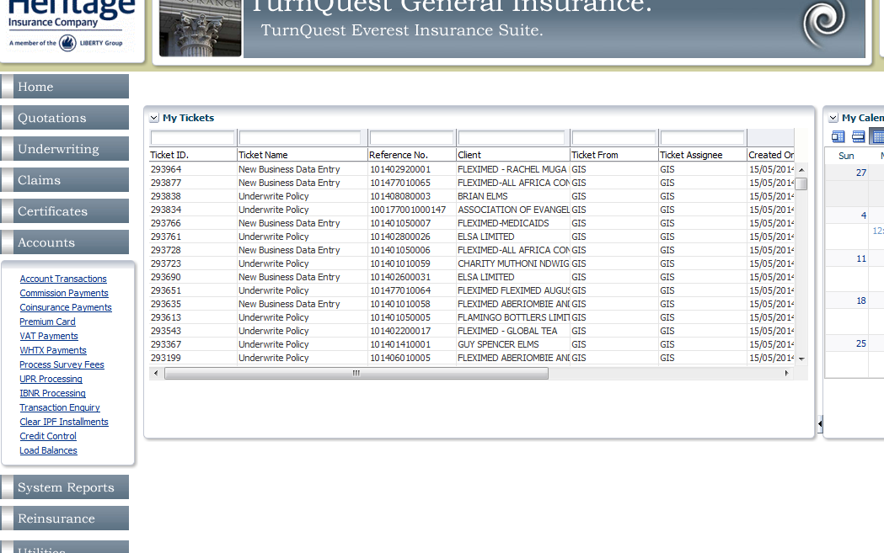

1. Accounts Transactions
   * Account Transactions
     + Post payment
     + Post Commission
     + Authorise Transactions
     + Tax remittance
   * Allocation of Credits against Debits
   * Allocation of Debits against Credits
   * Write-ins
   * Write-offs
2. WHTX Payment
3. Processing of Survey Fees
4. Reinsurance Remittance
5. UPR Processing
6. IBNR Processing
7. Credit Control/Master Enquiry
8. Transaction Enquiry
9. Coinsurance Payments
10. Clear IPF Installments

## **Post Payments**

This enables creation of requisitions for payments done due to refunds.

Payment posting is done to pay refunds in the case of policy cancellations and reversals. Cheque requisitions are sent to finance to effect the payment to be made to the recipient.

**Accounts>> Accounts transactions>> Post Payments**

* screen.

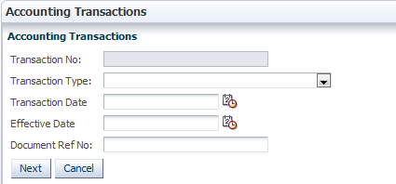

* Click  and select ‘Account Transactions/Authorization’ to populate the ‘Transaction Type’ field.

: The ‘Transaction Date’ and ‘Effective Date’ fields are populated automatically with the current date. They can be changed by clicking  and selecting a desired date.

* Specify a document reference in the ‘Document Ref No’ if necessary.
* Click  to proceed to the next screen.

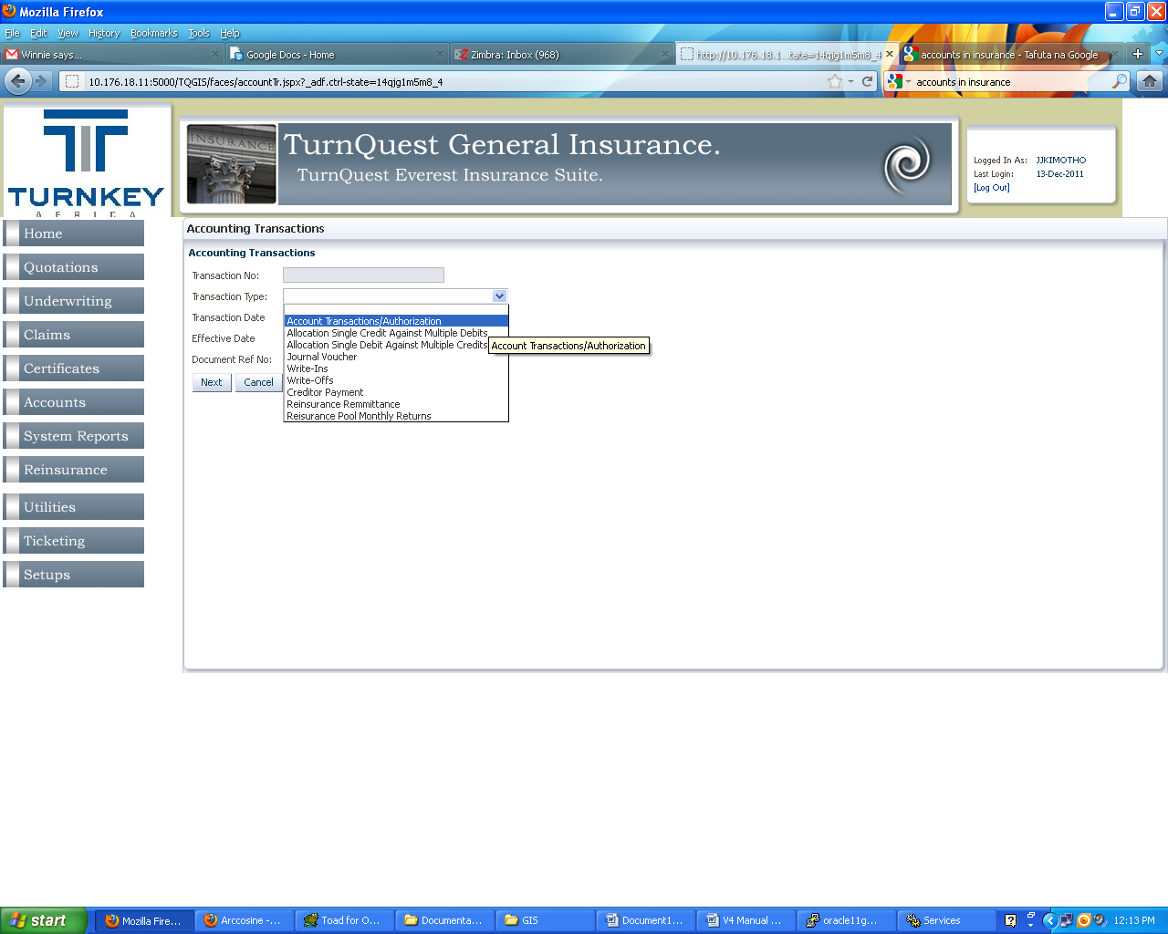

Select Account Transactions/ Authorization from the drop down on the accounts transactions screen to access the Posting Screen and select Post Payments options from the Choose option list as shown below

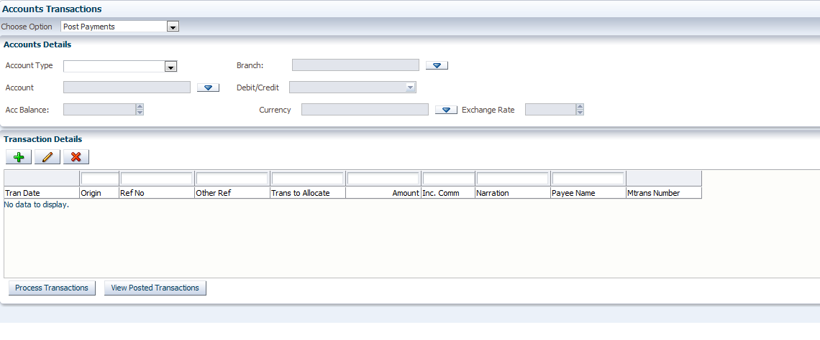

* In the ‘Account Details’ section, click  and select the account type.
* Selecting ‘DIRECT’ indicates that a direct client is paid directly.
* Selecting an intermediary indicates that the funds will be paid to the client through the selected intermediary.

Select the account details that posting is to be done for. Select Account Type from the List of values, Branch, and Account. The account balance will be automatically populated; the default Currency is picked

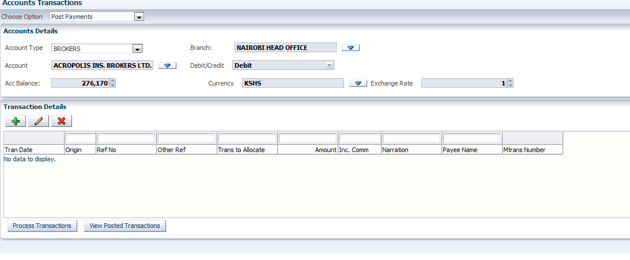

To create a payment transaction, Click on the add button on the Transaction details view, the below dialogue box is displayed

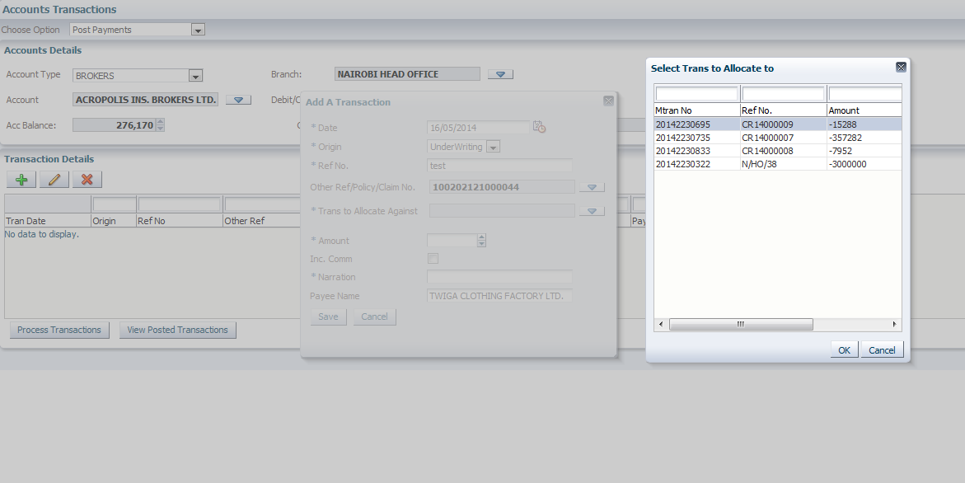

Date: Transaction/ Date payment was created

Origin: Claims/ Underwriting

Ref No: Key in the Reference no of the transaction

Other Ref/ Policy/ Claim No:

Transaction to allocate against: Select the debits/ credit to allocate to

Amount: Amount to be posted on that debit

Payee Name: Enter the Name of the Payee ( Name that will appear on the cheque)

* Select the transaction to attribute the payment to and click  to populate the field
* The ‘Inc. Comm’ checkbox indicates that the payment is inclusive of agent’s commission
* The ‘Narration’ field contains a description of the payment and the ‘Payee Name’ field contains the name of the payee.
* Click  on the ‘Add A Transaction’ dialog box to save the transaction details.
* Select the transaction and click 

***Posting Commissions***

This process is done in the event that an agent’s commission is deducted before a receipt is processed for a premium payment. In order for the commission payment to reflect in the GL, it has to be posted to the agent’s account.

**Accounts>> Accounts transactions>>Post Commissions**

* Click **Accounts** >> **Account** **Transactions** on the main menu panel. This brings up the ‘Account Transactions’ screen.



* Click  and select ‘Account Transactions/Authorization’ to populate the ‘Transaction Type’ field.
* Specify a document reference in the ‘Document Ref No’ if necessary.
* Click  to proceed to the next screen.

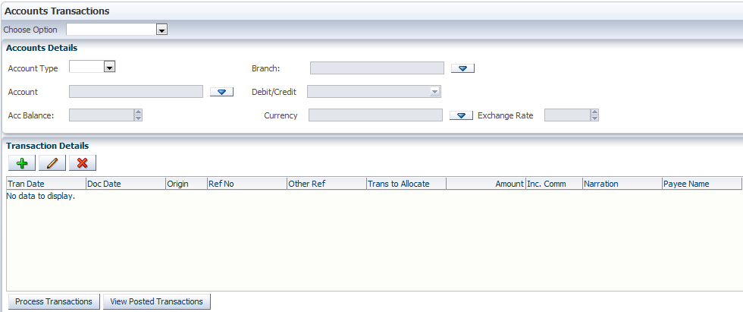

* Click  for the ‘Choose Option’ field and select ‘Post Commission’.
* Populate the ‘Account Details’ fields as outlined above in the ‘Post Payment’ process.
* In the ‘Transaction Details’ section, click  to bring up the ‘Add A Transaction’ dialog box as shown above
* Populate the fields as described in the ‘Post Payment’ process above
* Click  on the ‘Add A Transaction’ dialog box to save the transaction details.
* Select the transaction and click .

***Authorizing Transactions***

Transactions that have been processed from the processes above(posting payments and commissions) are to be authorized so that they are posted to finance.

**Accounts Module>> Accounts transactions>> Authorize Transactions**

To authorize payments Select Authorize Transactions from the choose option drop down as shown below

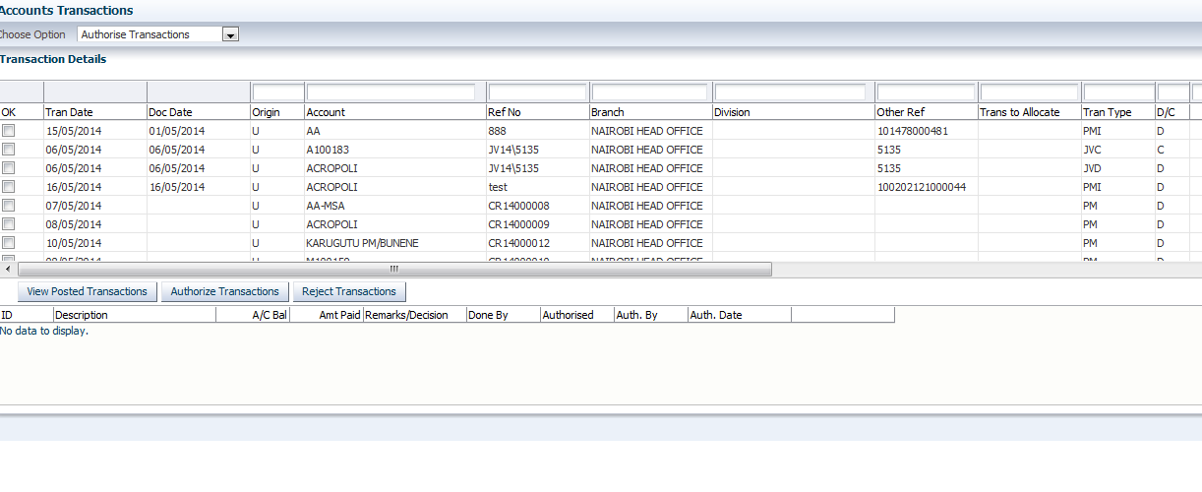

The authorize transaction screen is as shown below

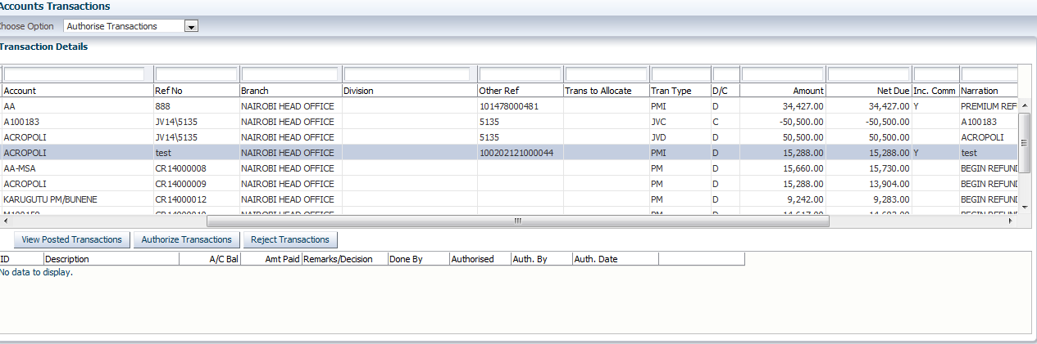

Transactions that are populated on this screen are: Refund Cheque and Payments

Verify the transactions to be authorized and click Authorize Transactions

To view posted transaction, Click View Posted Transactions, Enter the Run Report parameters and print report as shown below

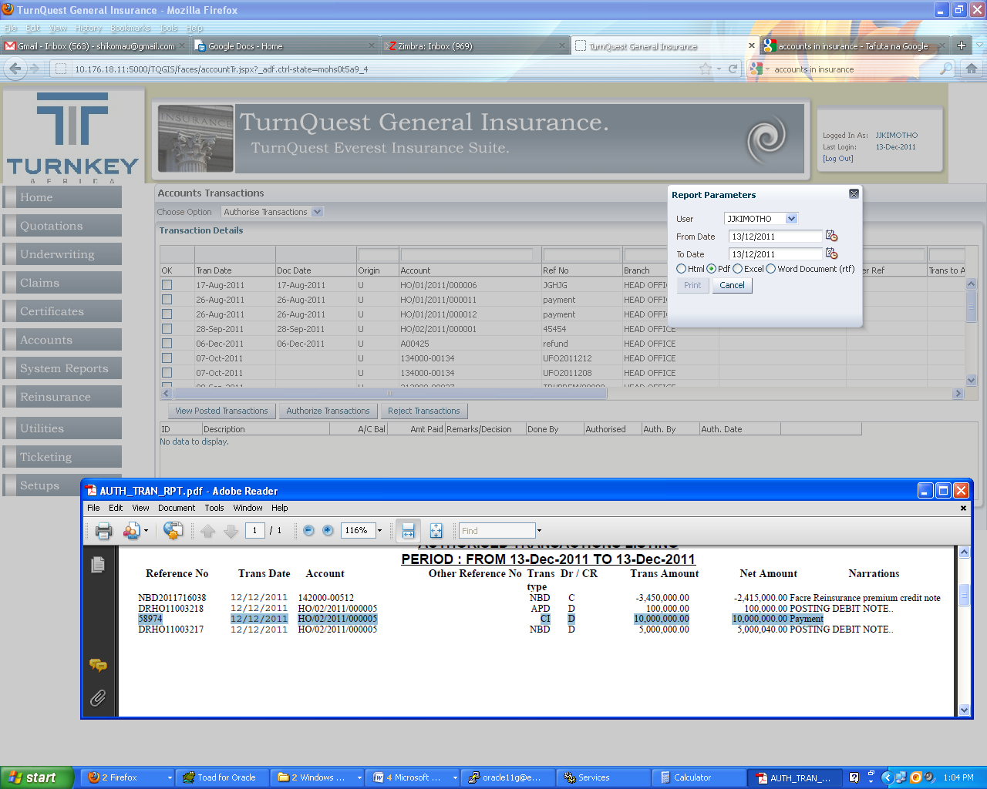

## **Allocating Credit against Multiple Debits**

**Accounts>> Accounts transactions>>Transaction Type: Allocation Single Credit Against Multiple Debits**

An agent could make a payment of a large sum to settle debits for several policies. Receipting on the agent’s account is first done in the FMS and then allocation of that credit to various policies is done in GIS.

TurnQuest GIS enables allocation of a credit against multiple debits, this can be as a result of

* Receipts done on account
* Refunds

***Allocating Credit To Policies After Receipting On An Account***

An agent could make a payment of a large sum to settle debits for several policies. Receipting on the agent’s account is first done in the FMS and then allocation of that credit to various policies is done in GIS.

* Click **Accounts** >> **Account** **Transactions** on the main menu panel. This brings up the ‘Account Transactions’ screen.



* Click  and select ‘Allocation Single Credit Against Multiple Debits’ to populate the ‘Transaction Type’ field.
* Specify a document reference in the ‘Document Ref No’ if necessary.
* Click  to proceed to the ‘Allocate Single Credit Against Mutliple Debits’ screen

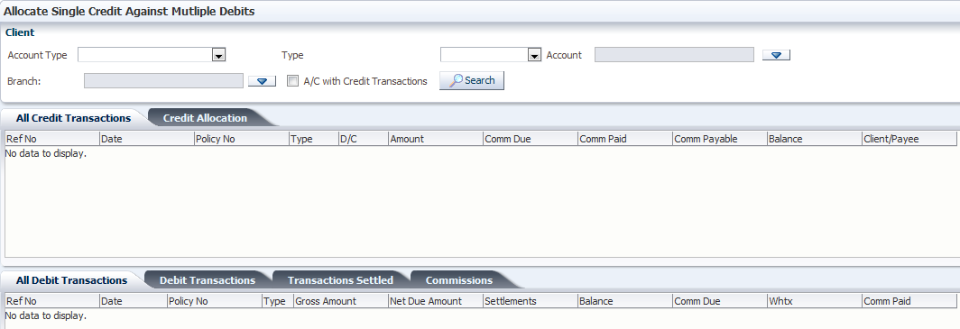

* Click  for the ‘Account Type’ field and select the account type from the drop-down list
* Click  for the ‘Type’ field and select ‘Premium Ceded’, ‘Premium Accepted’ or ‘Claim’
* Premium ceded is a receipt on a premium payment from another insurance company in a coinsurance or facultative business for example.
* Premium accepted is for a receipt of premium from a client or an agent being payment for the client’s policy
* Claim is selected if the payment is made in the event of claim recoveries
* Click  for the ‘Account’ field to bring up the ‘Select Account’ dialog box
* Select the account and populate the field
* Select the branch for the business and populate the ‘Branch’ field. The ‘All Credit Transactions’ tab is populated with a list of all credit transactions done on that account. The ‘All Debit Transactions tab’ is also populated with all the debit transactions done on the account.

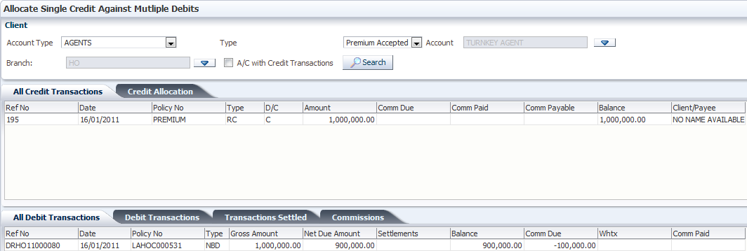

* Go to the ‘Credit Allocation’ and ‘Debit Transactions’ tabs to view credits that have not been allocated and debit transactions that have not been settled respectively.

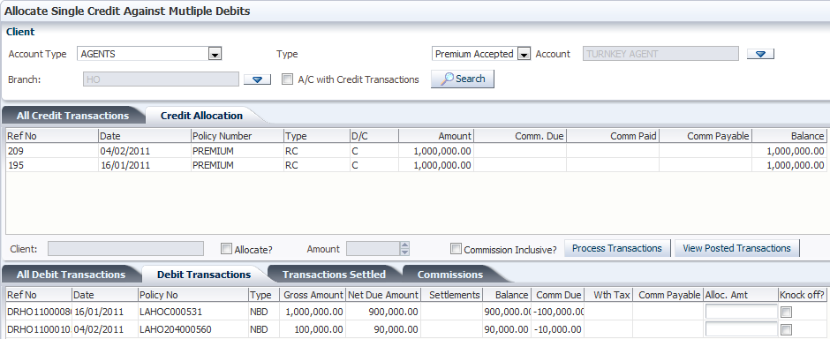

* Under the ‘Credit Allocation’ tab, select the credit with which to knock off debit amounts
* Under the ’Debit Transaction’ tab, against the debit transaction that is to be settled, check the box on the ‘Knock Off?’ column. This automatically populates the box on the ‘Alloc. Amt’ (allocation amount) column with the net due amount.

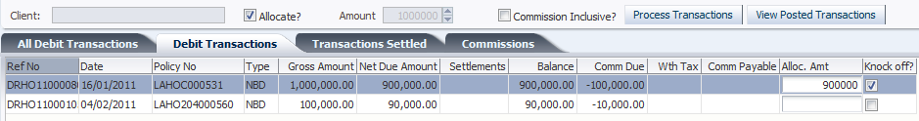

* Change the allocation amount to the actual amount intended to be allocated
* Check the ‘Commission Inclusive?’ box to indicate that the allocation amount is inclusive of the commission due as shown in the ‘Comm Due’ column
* Click  to process the transaction

: The knocked off debit is removed from the list after processing the transaction

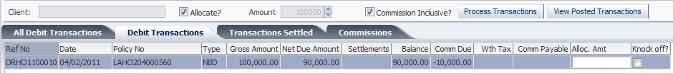

* Go to the ‘Transactions Settled’ tab to view transactions that have been settled

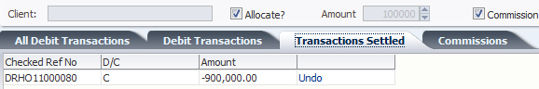

#### **Scenario of a receipt allocated in Fms**

If a debit had been allocated in FMS there will be no debit transaction to do an allocation to. The balance due will be due to the commission. Hence a commission payment should be done. In case the transaction was allocated wrongly. On the Transactions settled Tab click on undo, this returns the allocation to the account. From the below transaction once queried there are no debit transactions available for knock off

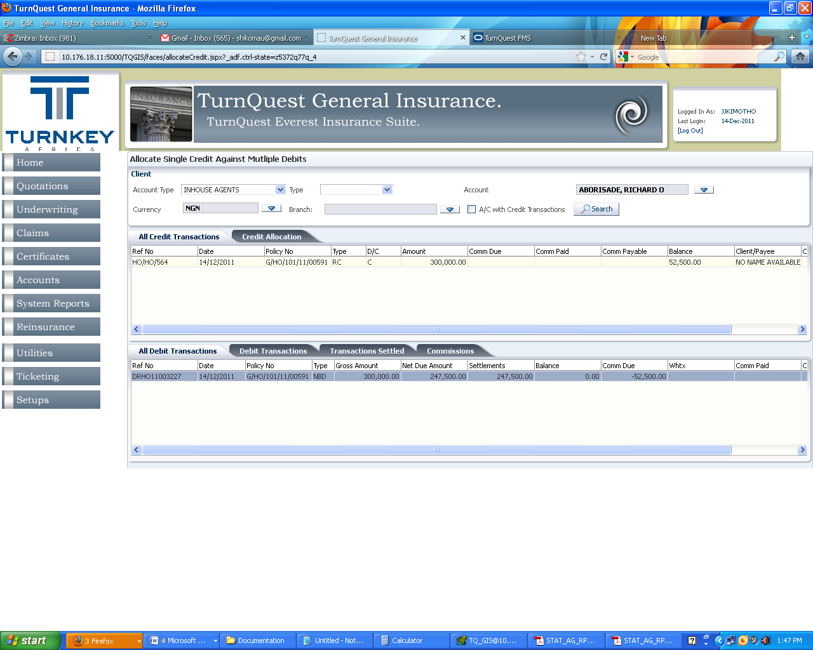

Balance on the debit is zero, Commission due is 52500 hence commission has to be processed ***(see topic Commission Processing)***

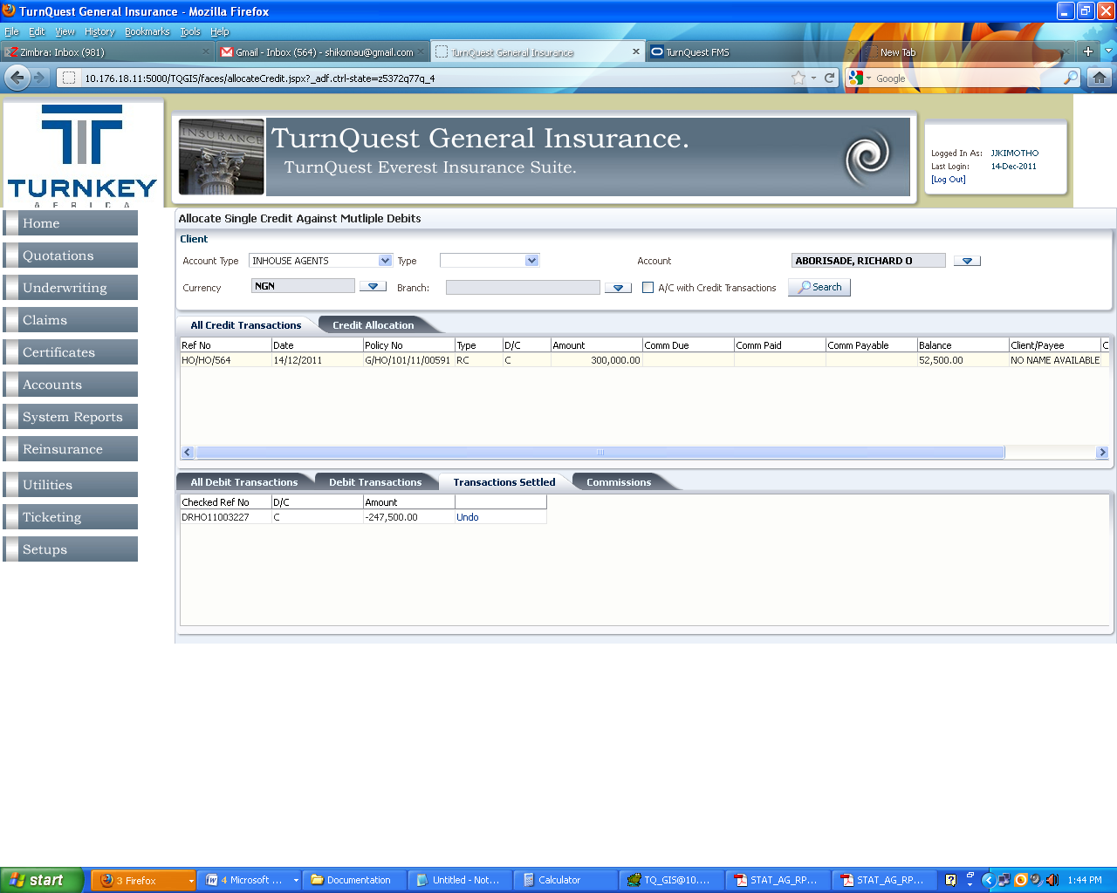

As shown below commission payment was done and the balance on the account is zero. 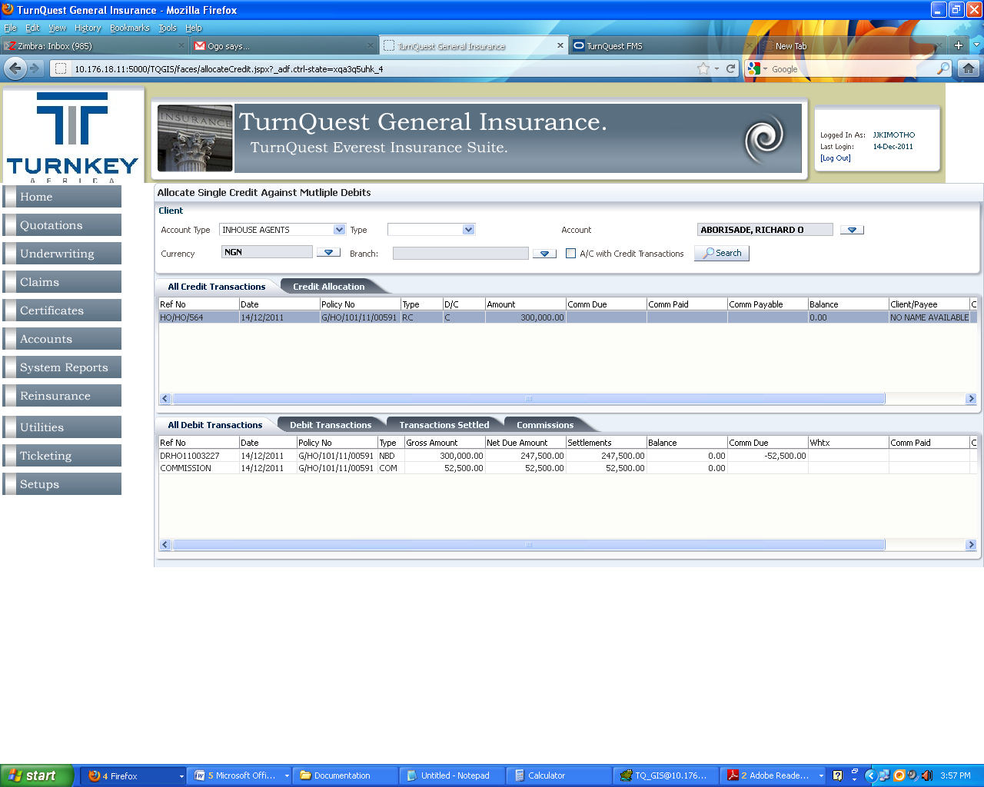

#### **Undo Transactions**

Click on the transactions settled tab as shown below

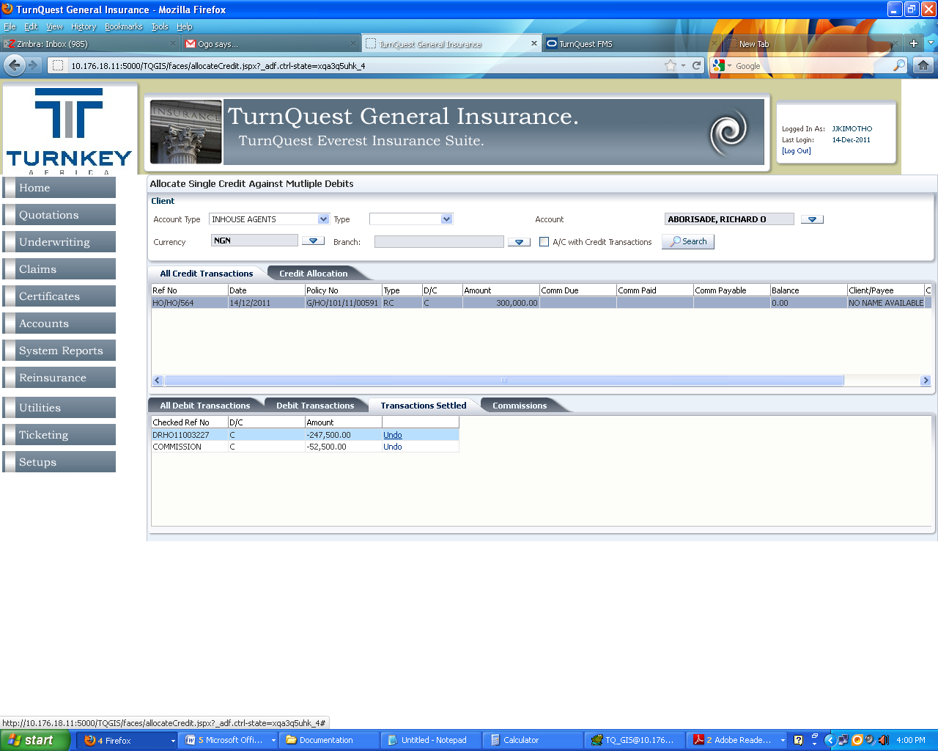

Select debit and click undo. It will create a debit transaction as shown below. This reverses the allocation

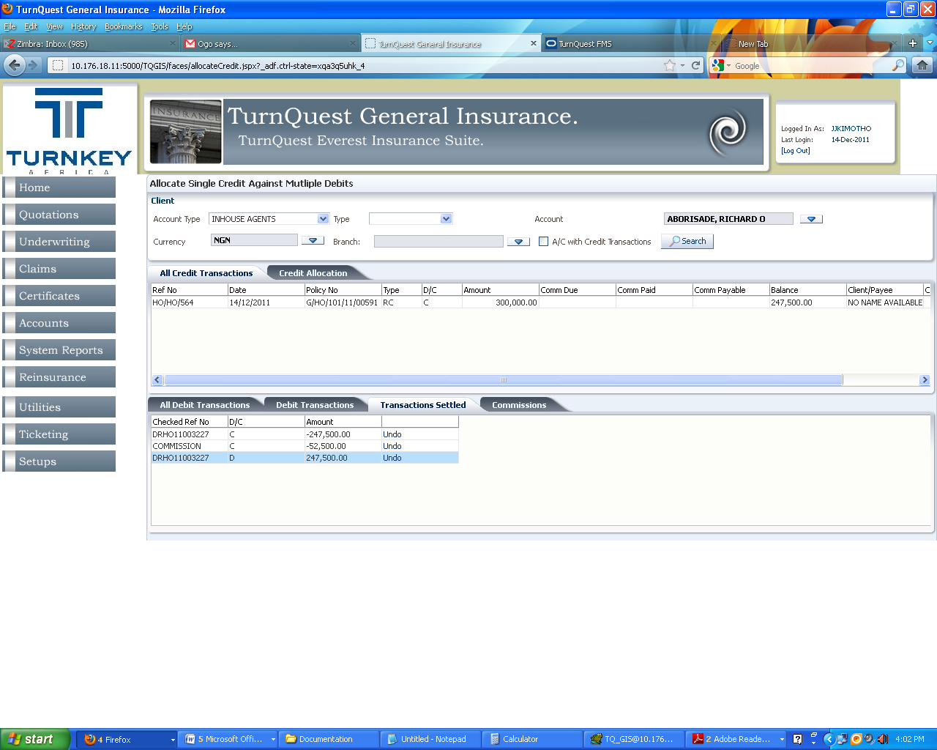

**Note:** System does not allow undoing twice

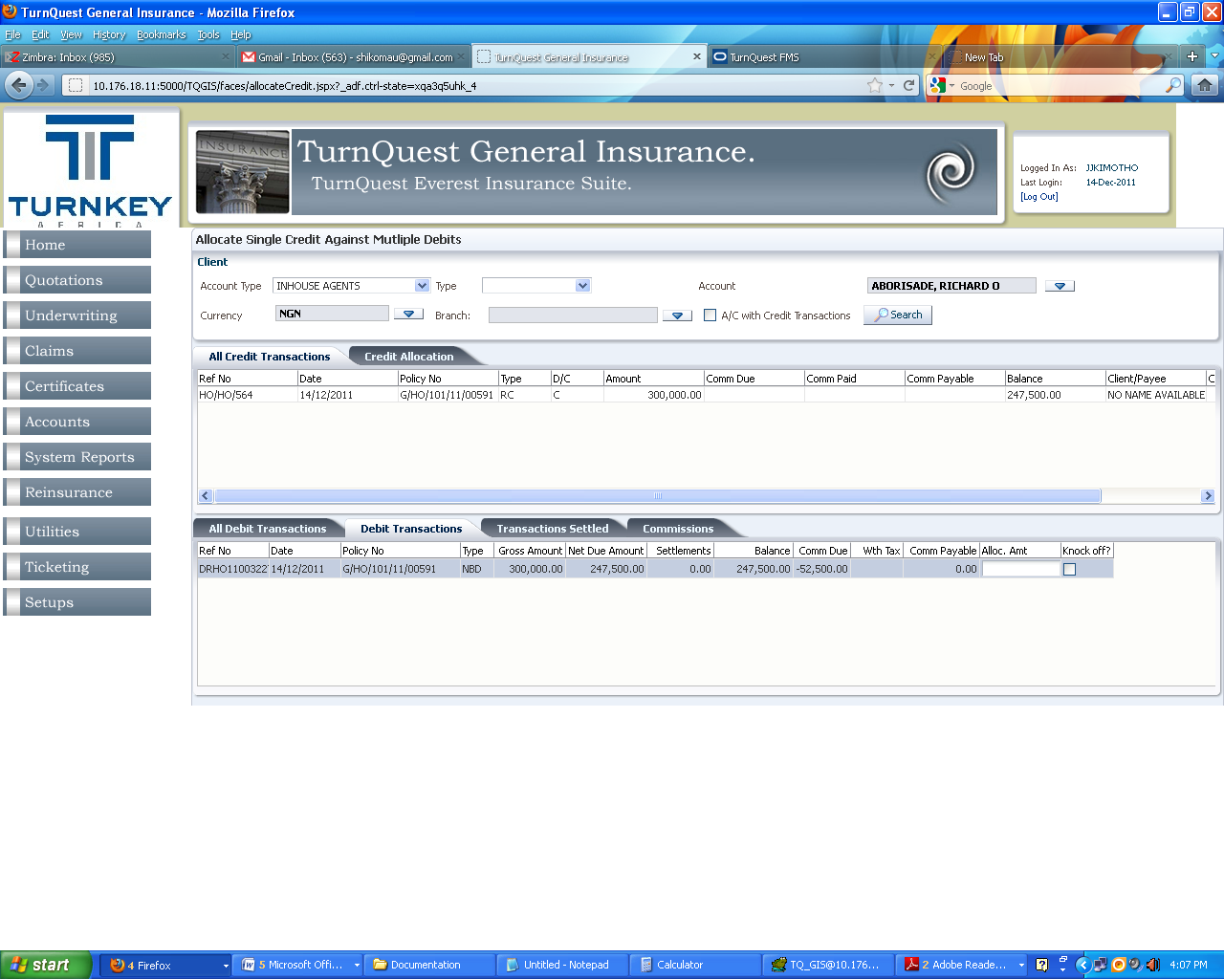

The balance on the account is updated and the debits are updated back to the Debit Transactions

## **Commission Processing**

**Accounts>>Commission Payments**

This enables the processing of commissions for agents. Once processed a cheque requisition is made to TurnQuest FMS for payments

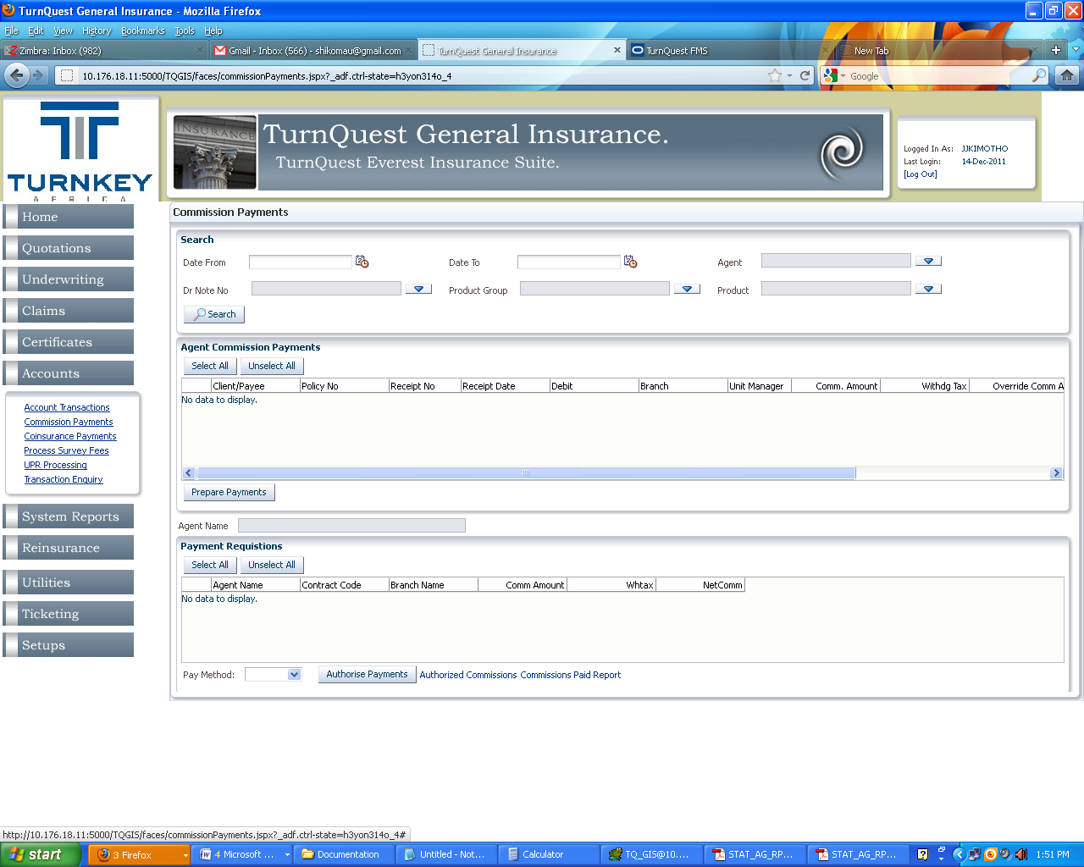

Select the date from and date to (transaction dates), Select Agent with pending commission payments, to refine the search select Debit Note no, Product Group and or the product and click search

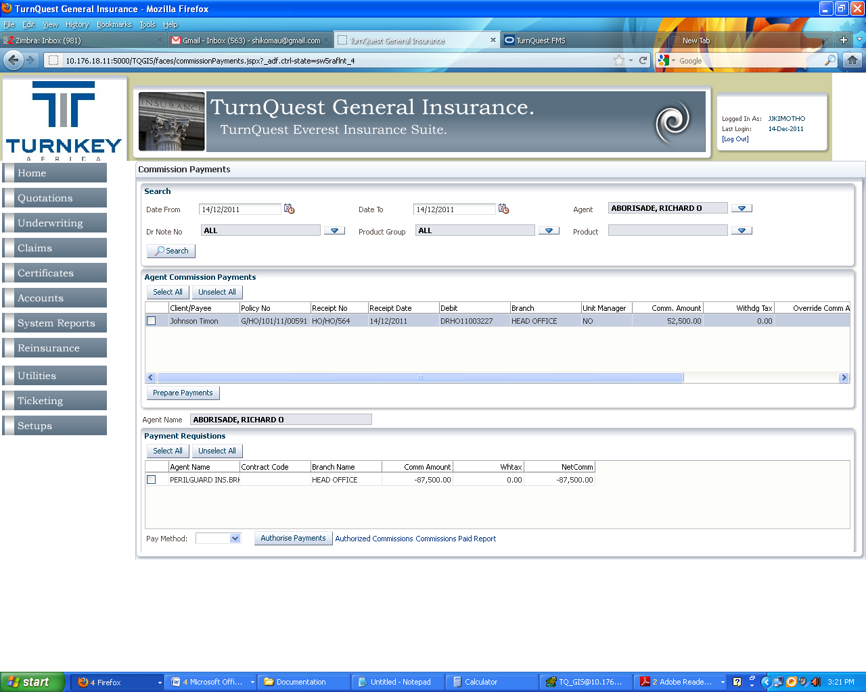

Commissions due for processing are populated. Select transaction(s) and click Prepare Payments as shown below

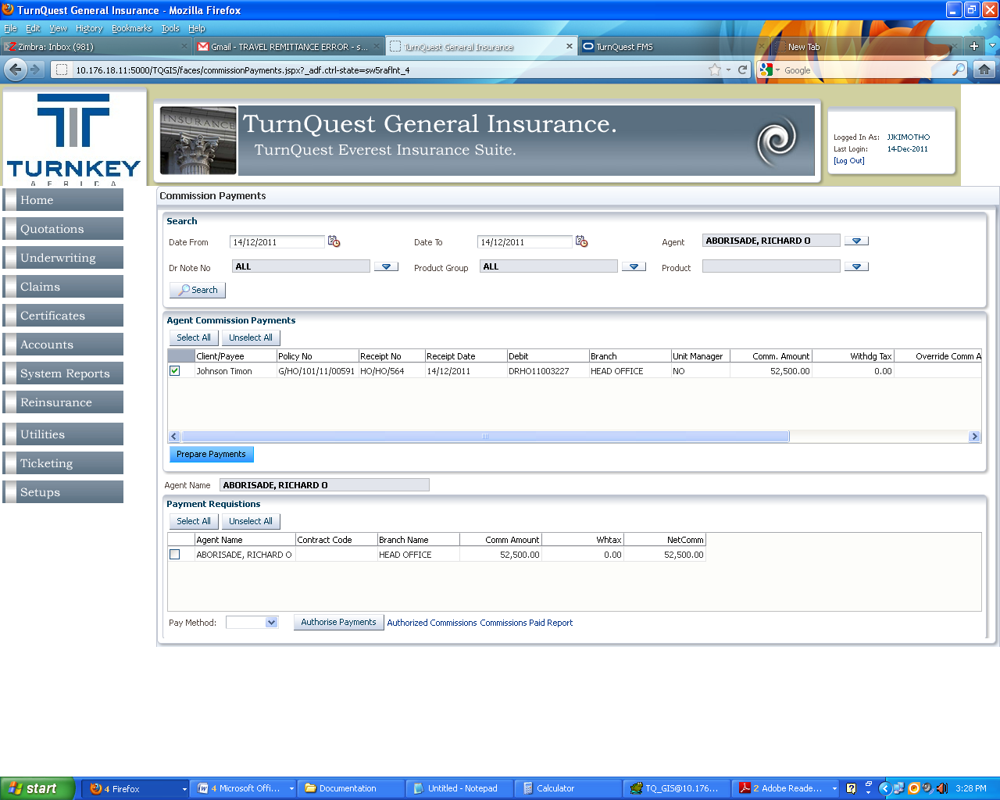

**Note:** If there are multiple payments consolidation is allowed in-order to raise one requisition for payment. 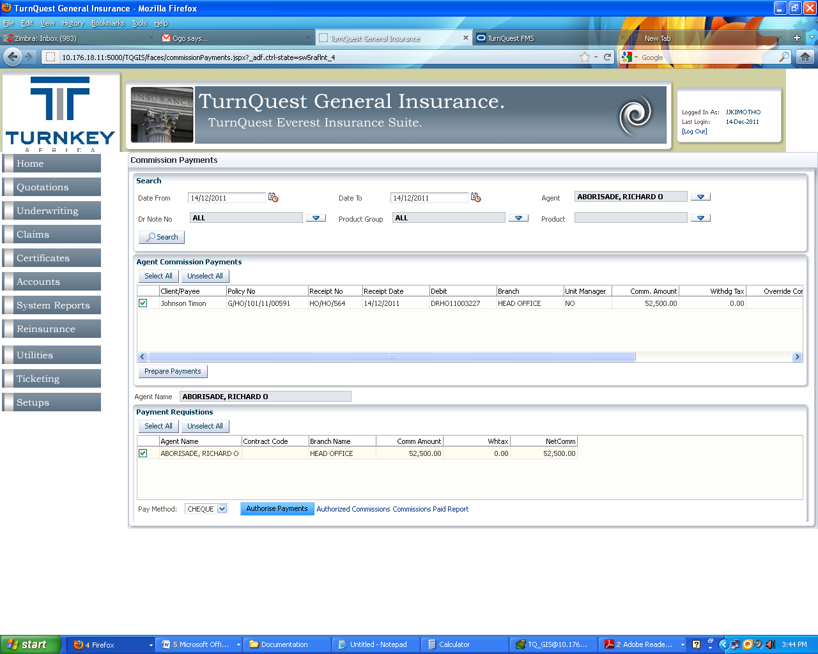

Select the Agent, Payment Method and Click Authorize Payment. This will generate a cheque in TurnQuest FMS

## **Journal Vouchers**

**Accounts Module>> Accounts transactions>>Journal Vouchers**

In TurnQuest GIS this transaction type is for Debiting one account and crediting another account. This transaction is not posted to finance

Select Journal Voucher from the Transaction Type drop down and click next. Transaction and effective dates default to the system date as shown below

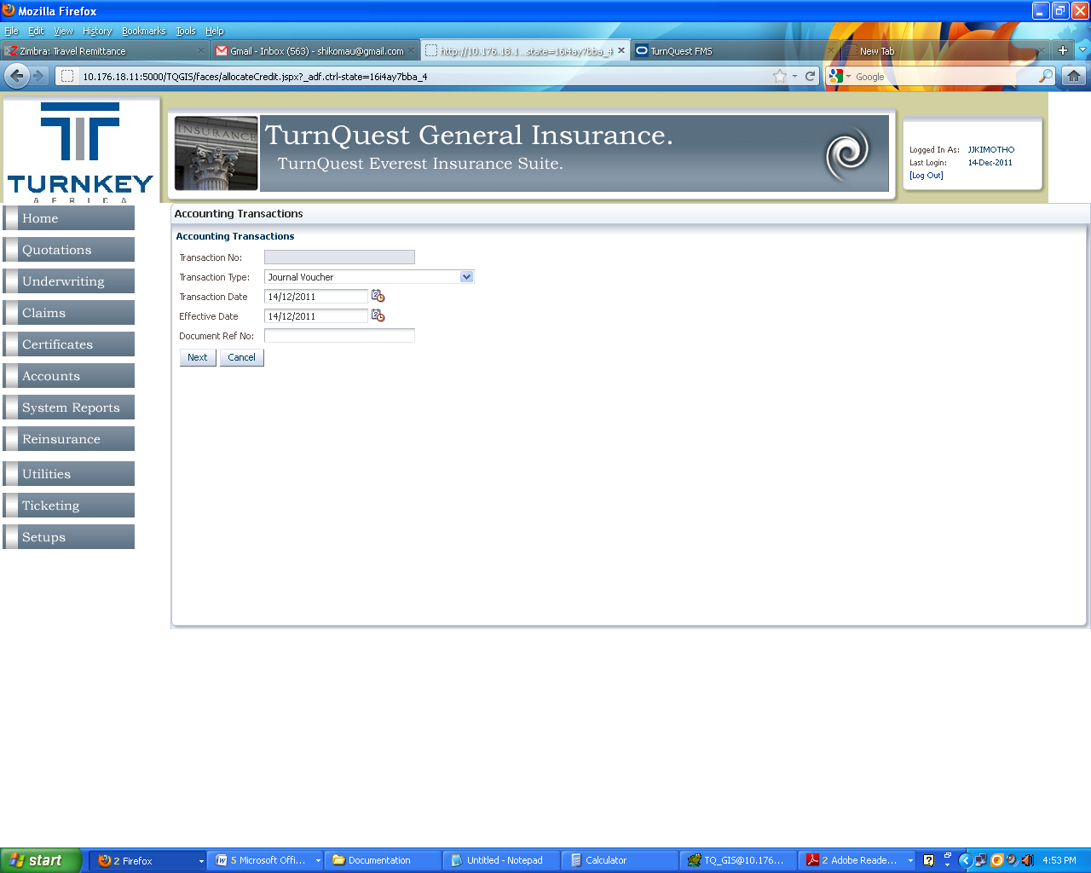

Select the date, Origin of the JV (underwriting / claims0 and the currency. A voucher number is automatically generated (JV Ref No)

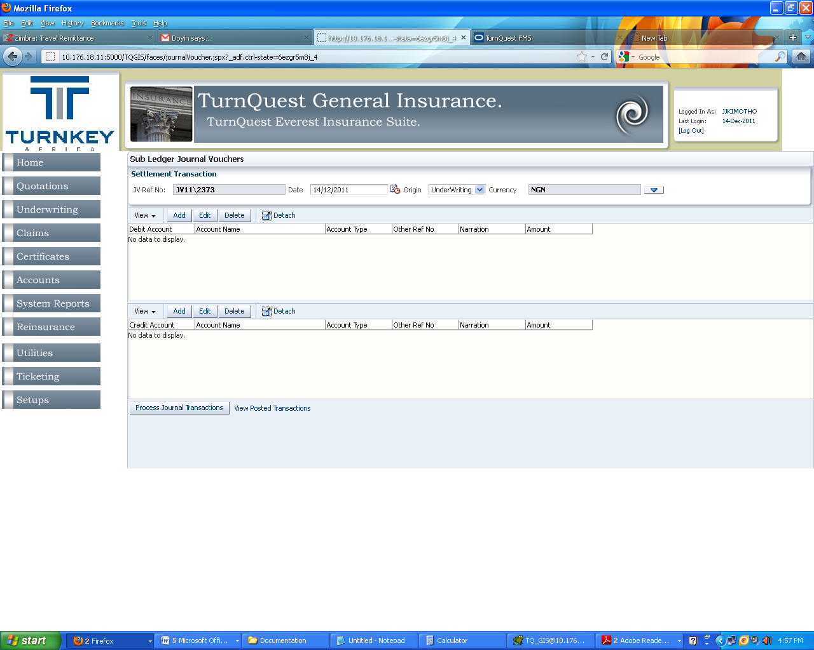

The top view is for selecting the account to be debited while the bottom view is for account to be credited.

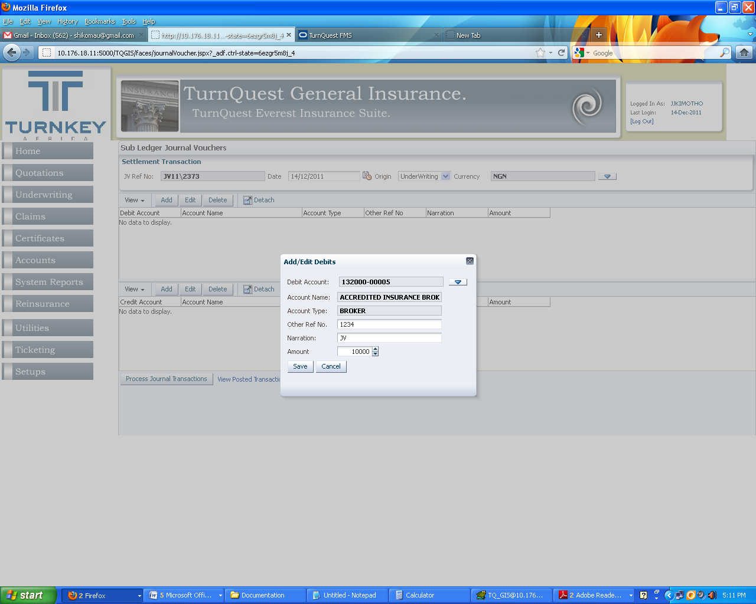

Click on add to select the account to be debited. Enter Ref No, Narration and the amount and save

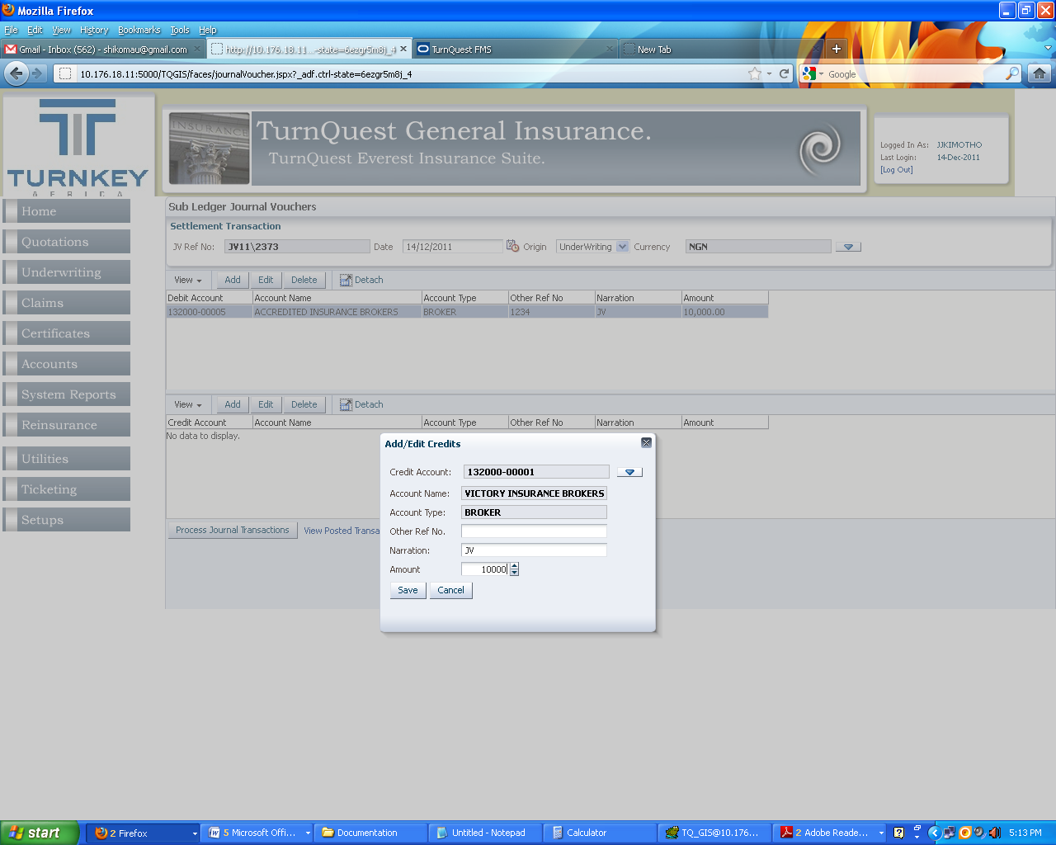

Select account to be credited should be of the say account type as the debit. Enter Ref No, Narration and the amount and save

Note: Account Type, Amount should be the same

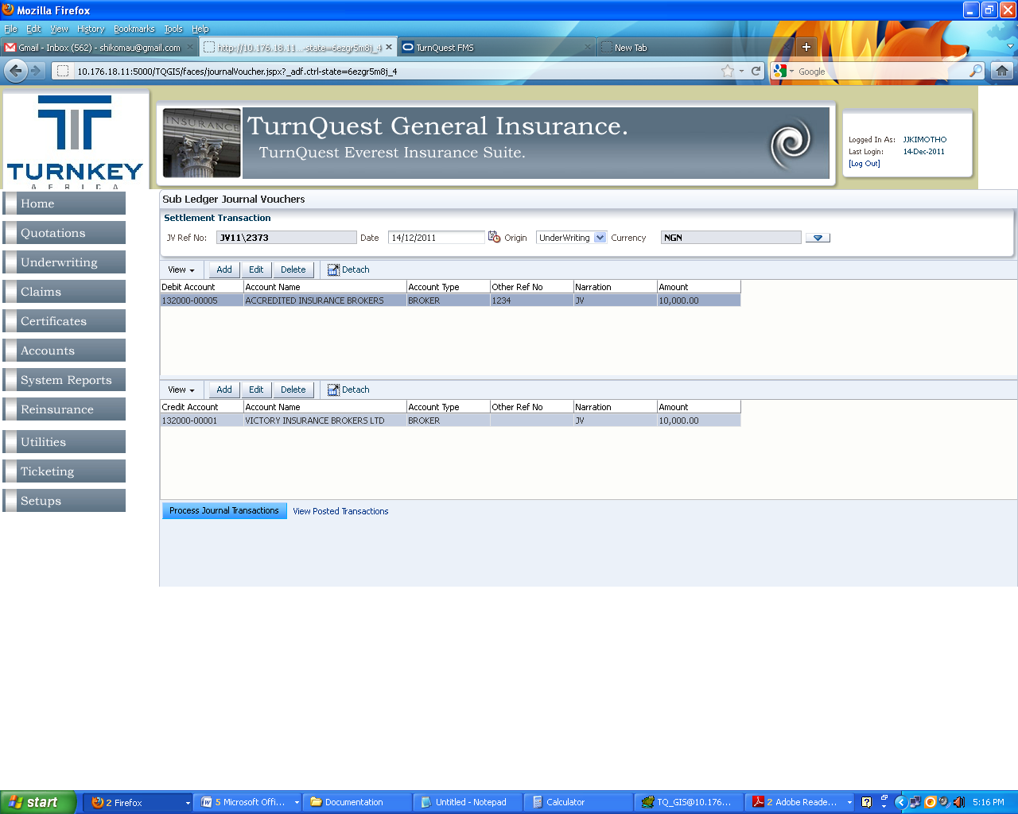

Click Process Journal transaction

Authourize a Journal Transaction

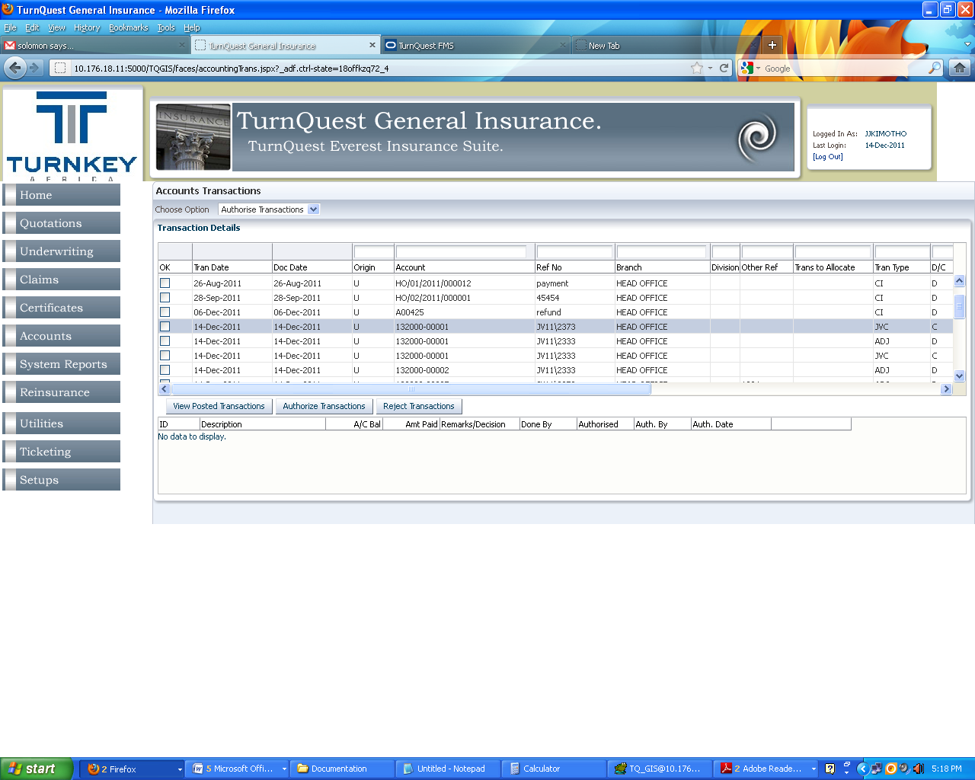

***Unearned Premium Processing***

* Click **Accounts** >> **UPR Processing** to bring up the ‘UPR Processing’ screen

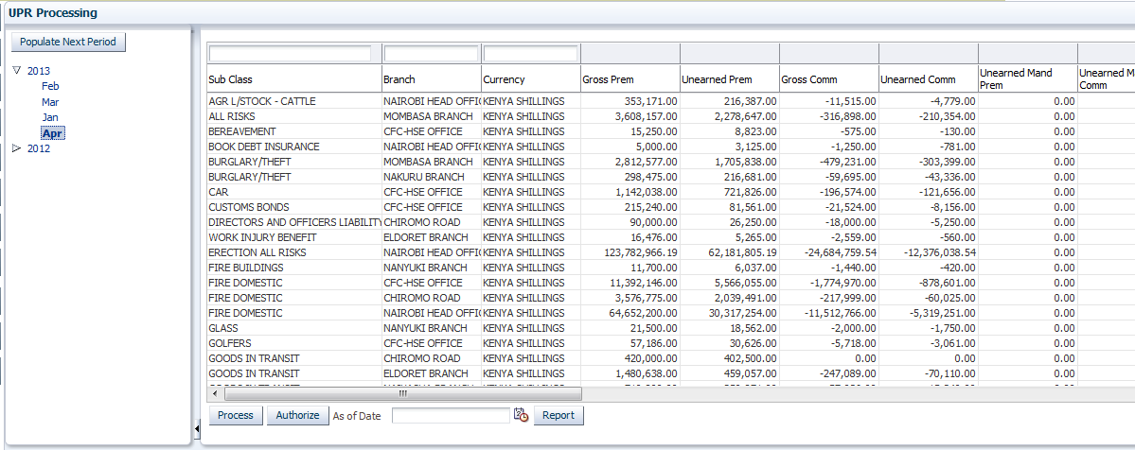

* Select the last period and click on the populate Next Period button to populate the next period
* Enter the **As of Date**
* Click on the Process button to calculate the UPR figures
* Click on the Authorise button to post to FMS

## **WHTX Payments**

This screen is used to generate payment of withholding tax refunds for payments made to service providers. i.e when making fee payments for claims

* Click **Accounts** >> **WHTX Payments**  to bring up the ‘whtx Processing’ screen

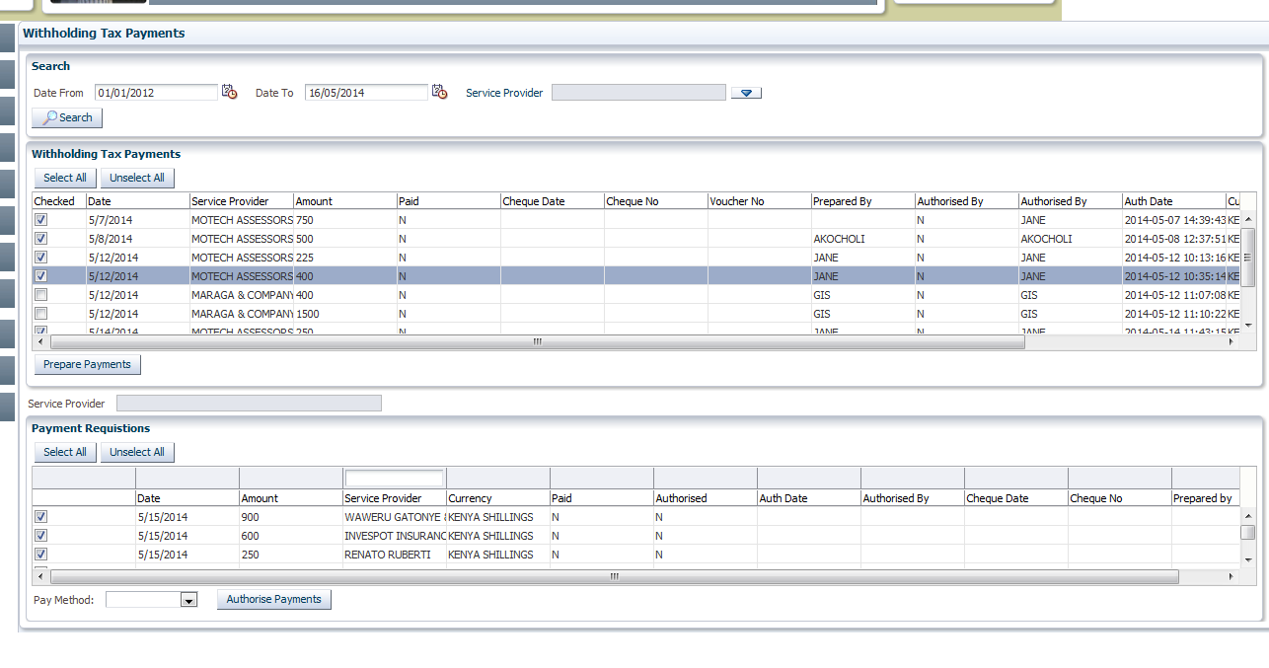

* Capture the Date from and Date to  
  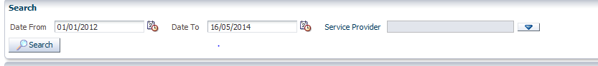
* Click on the search button to populate all payments done for the specified period.
* Click on select all button and individually select the payments to to be processed for withholding tax
* Click on the prepare Payments button

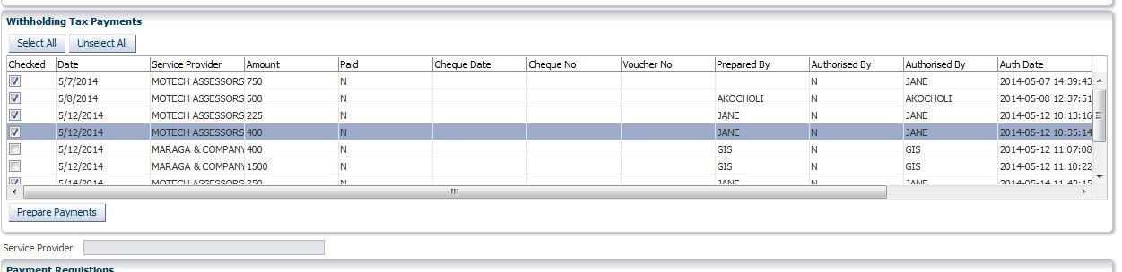

* Once prepare payments is done , The requisitions items are populated

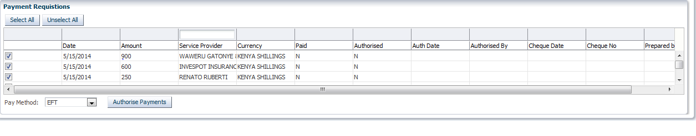

* Choose the Pay method and click on the authorize Payment button.
* This creates a requisitions for refunds to service providers in FMS

## **Master Enquiry**

This screen is used for all enquiry of a policy from a single screen . You can get the account details , claim details, claim experience reports and valuation details from a single screen

* Click **Accounts** >> **Master Enquiry**  to bring up the screen

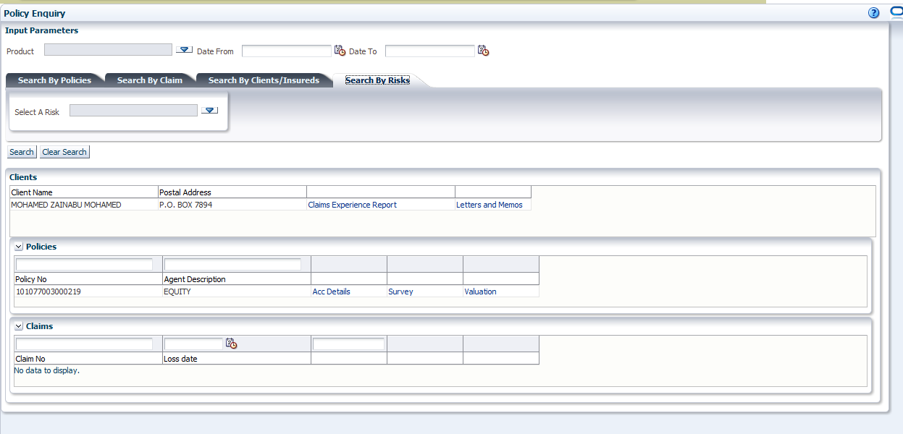

* Optionally select the product and the date from and date to

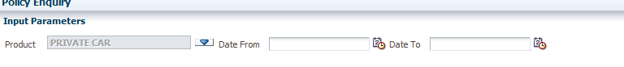

* There are options to search by policy, claim, client/insured or by risk. Choose one

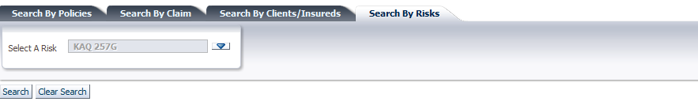

* In this example we search by Risk, then click the search button to populate detail blocks below

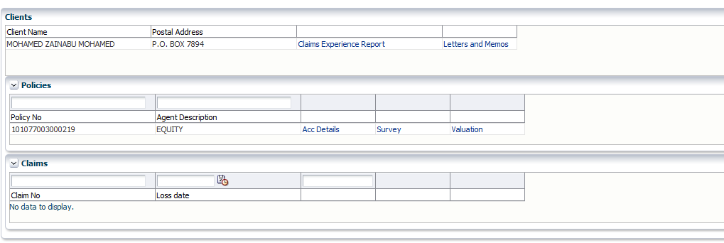

* From the detail blocks below the following information is available by clicking on the respective links ; Claim experience, Account details. Survey and valuation information

## **Clear IPF Installments**

This screen is used for clearing pending IPF Installments that have been cleared with the Bank.

* Click **Accounts** >> **Clear IPF Installments**  to bring up the screen

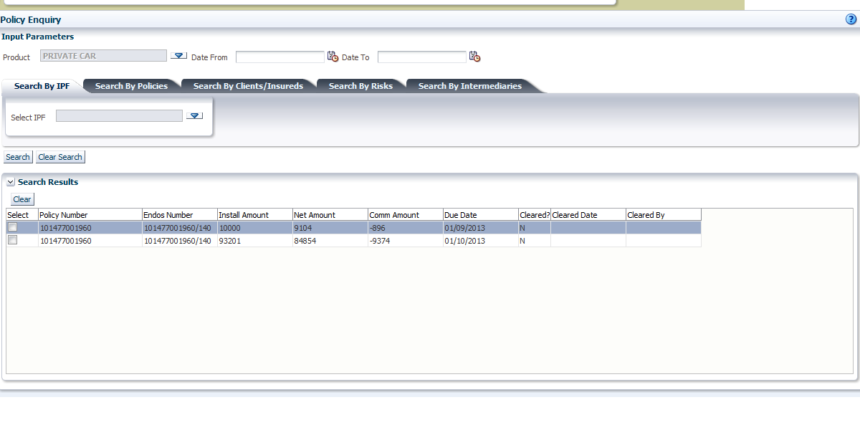

* Select the product , date from and date to



* Avilable options to search for pending installments are as shown below



* Click on the search button to populate the uncleared installments based on the search criteria
* 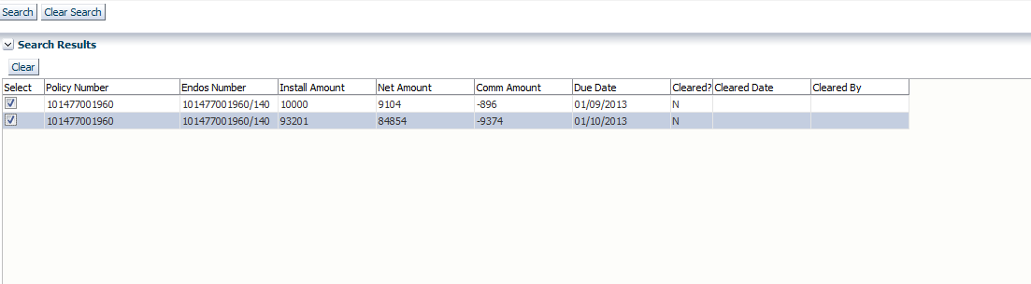
* Check the installments that have cleared and click on the Clear button
* 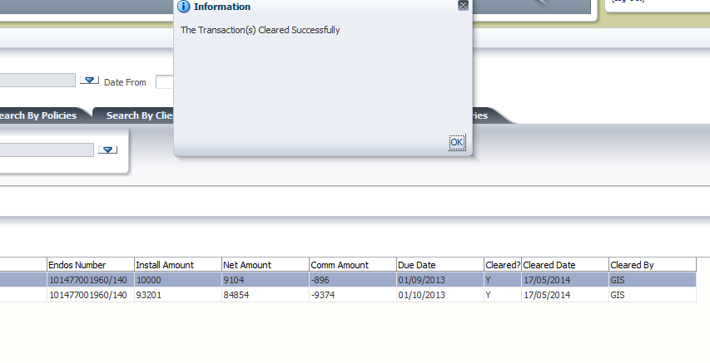
* The Cleared Installments can now pay commisions , in the next commsion run.

## **Write Ins/ Write Offs**

These provide a way to settle client accounts by the use of accounting GL entries. These may occur in for example when a client to settle his existing debt in kind or when the Insurance company decides to write off bad debts.

* Click **Accounts** >> **Accounts Transactions** to bring up the screen

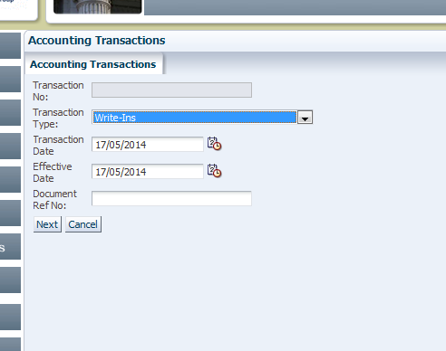

* Select write in or write off depending on the transaction you are carrying out
* Capture the effective date and the reference number if any.
* Click on next button

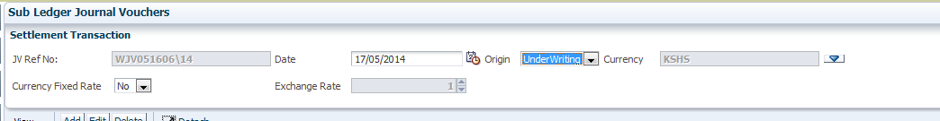

* On the next screen capture the JV date and the origin
* The other details are auto-populated based on default settings

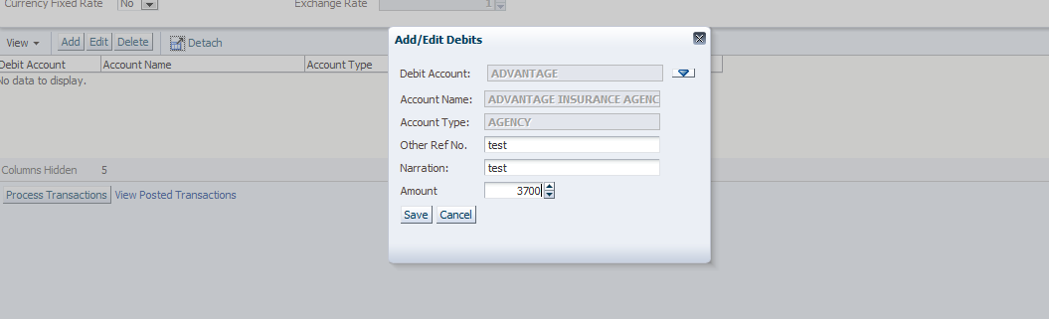

* Click on the add button to capture account details for the sub-ledger account . Capture the ref no, Narration and the amount
* Click save when done

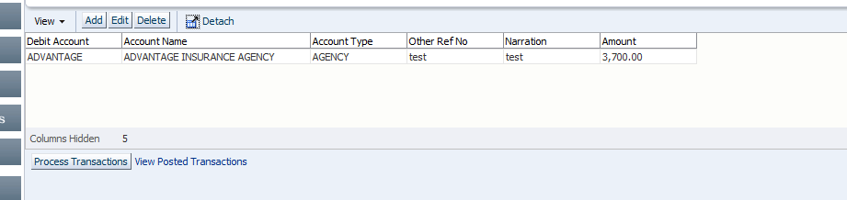

* When finished adding , click on the process Transactions button
* Click on the View Posted Transactions link to view a report of the same
* The journal entry has now moved to the Authorize transactions area (discussed earlier) for MS

**Travel Deposit**

This functionality is used on travel products where a client would deposit moneys with the insurance company onto a suspense account which can later be used to allocate onto the clients travel policy each time the client travels.

Select **Underwriting Module>>>Administration Fee/Travel Deposit**

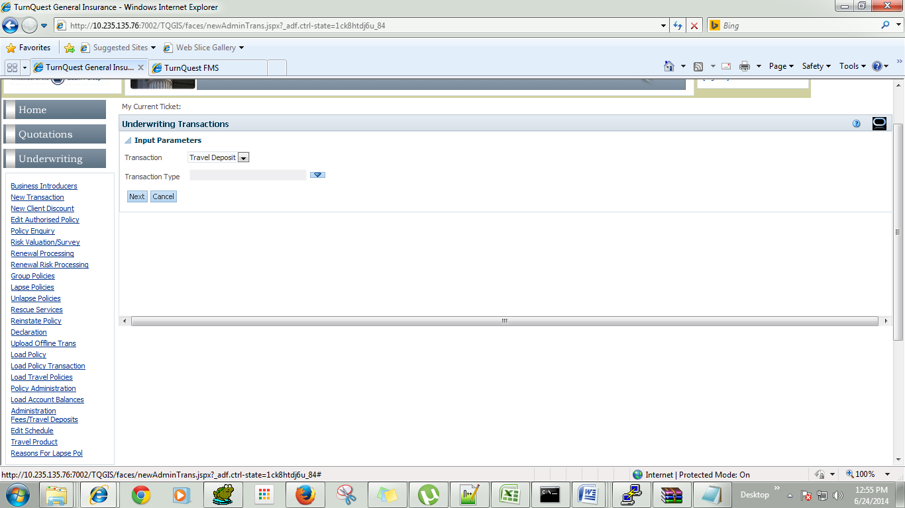

Select Travel Deposit:-

New Transaction:- To specify the deposit amount for a given client

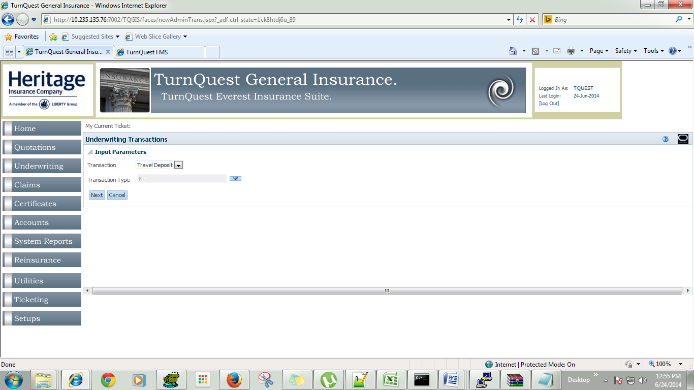

Select the client, Branch, With Effect From, and To and the total amount

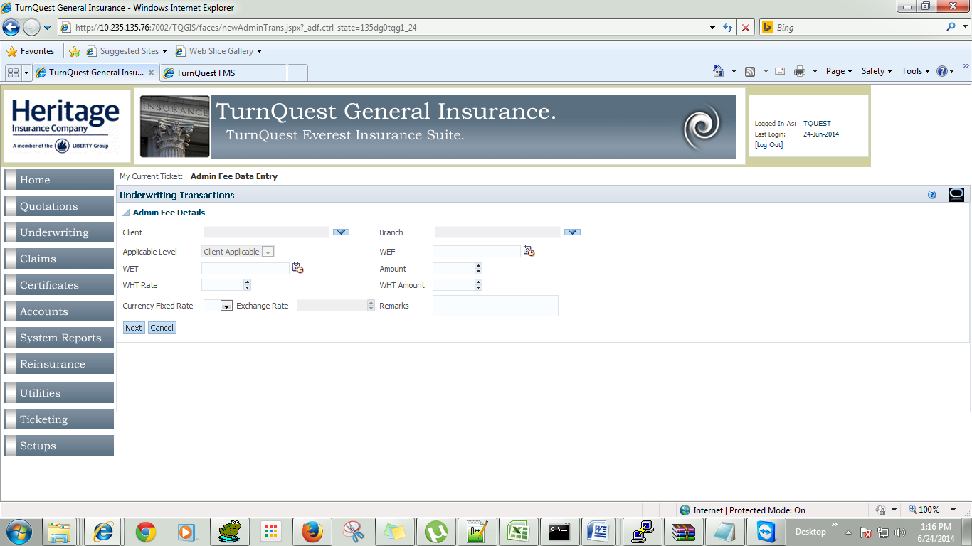

Then authorize the Deposit raised.

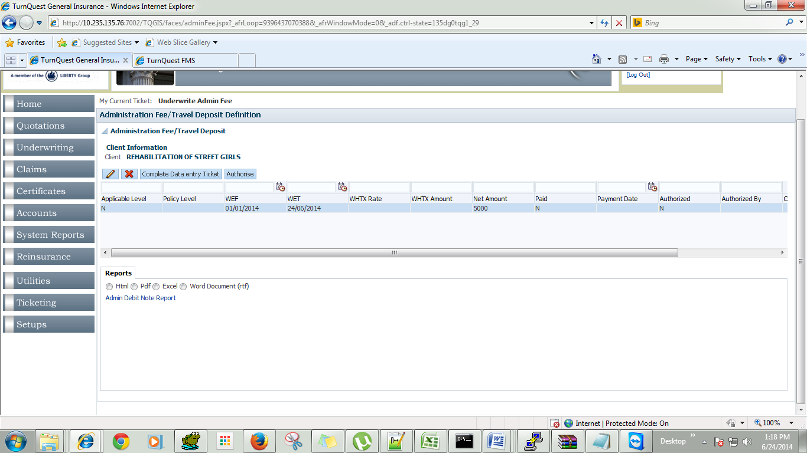

For allocation of the deposits raised Go to the

**Accounts Module>>Account transactions>>Allocate Travel Diposit Transaction**

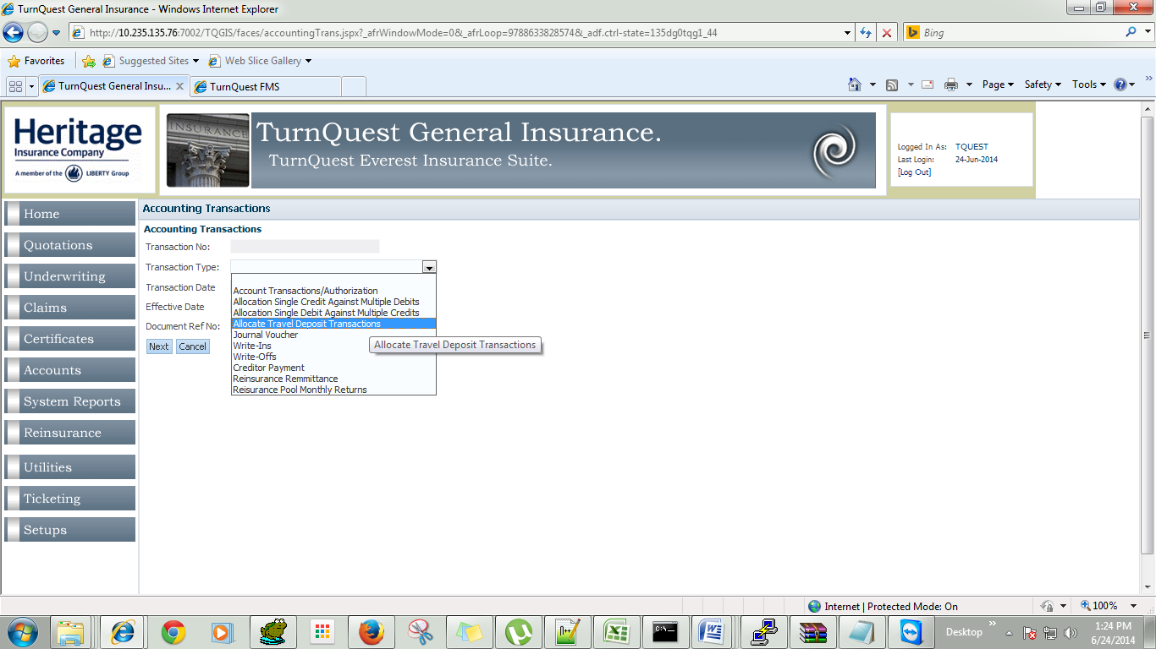

For Allocation select the client record to allocate by selecting the client search for existing credits (Travel deposit credits raised) Then allocate to the travel policies generated(Debits) for that client.

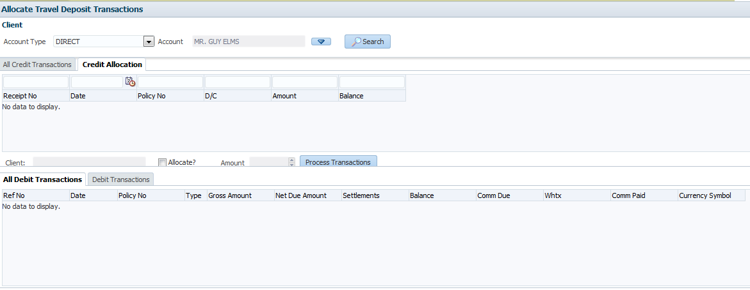

**With Holding Tax refund generation for Claims Service Providers**

This functionality provides withholding on service provides for the services provided at the end of every month. The condition to be check is whether the accumulated gross of there fee amount is less that 24,000/= if so a refund cheque is raised which is then consolidated on the raised net fee amount.

Go to **Accounts Module >> WHTX Payments**

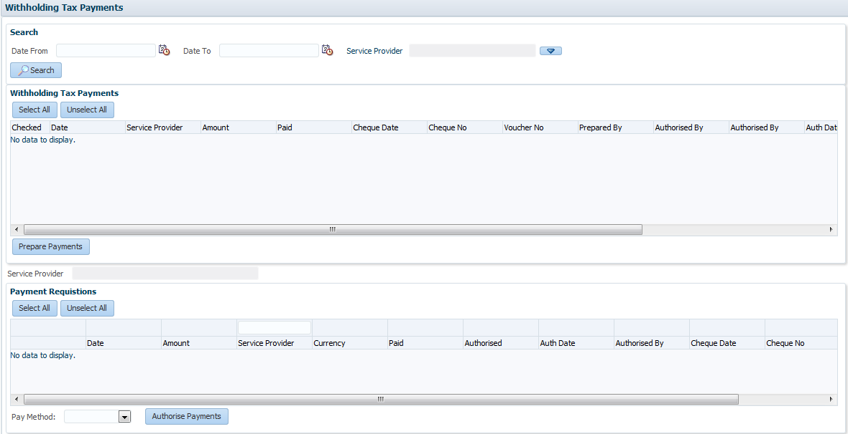

**Tax remittance**

This is to raise a cheque requisition to Finance for payment of Tax to the regulator.

Select Account Transactions>>>Tax remittance

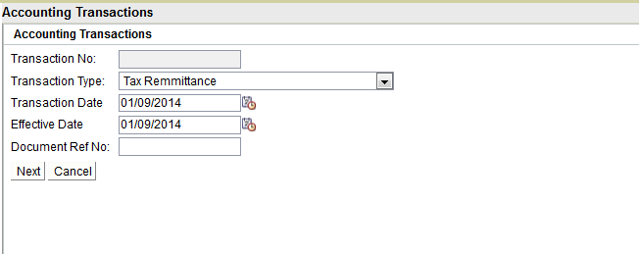

Select the choose to which the tax is to been paid. Specify the period which transactions range from and state the Payee name

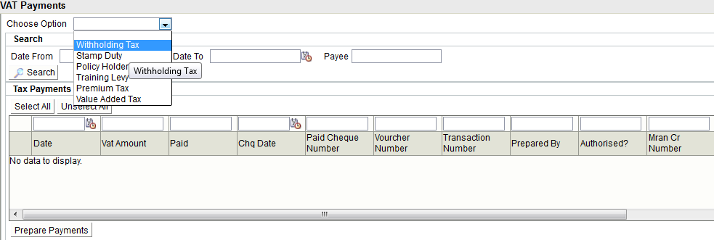

Hit **prepare Payment** to make the Cheque transaction ready for requisition. The payment is then authorized at the lower table stating the payment mode.

